Note: Include this page only when adding / amending / deleting a document. If using this document as a record, this Revision History page can be omitted.

REVISION HISTORY

Revision no | Date | Description of Changes | Reason for Revision | Revised by | Approved by:
00 | Feb. 5, 2016 | Transferred the document from Service Delivery unit to Geniisys Services Unit | SD unit is obsolete | ASRosario | RCGanal
TM-BR-MG-11 Rev02, 10302015

- OBJECTIVE

To ensure the delivery of all tasks required to implement a GENiiSYS system on time, on budget and according to the agreed scope agreed by the client

- SCOPE

This procedure is for the company’s insurance systems.

This procedure defines the actions and responsibilities of the Project Team in implementing the system. This covers activities from project kick-off to live implementation.

- DEFINITION OF TERMS

- PROCEDURE DETAILS
RESPONSIBLE | ACTIVITY | INTERFACE
Project Manager  Project Manager  Account Manager  System Analyst  Project Manager  Implementation Team | 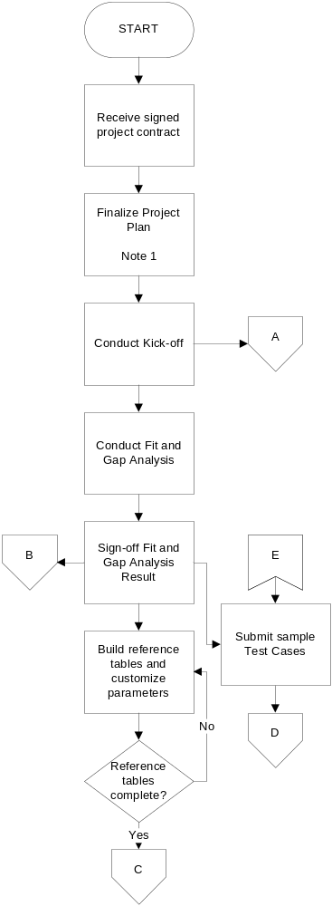 | Business Development  Refer to V-A, VI-A  Client  Refer to V-B  Client  Refer to V-C, VI-B  Client  Refer to V-D, VI-C  Client  Refer to V-E, VI-D  Refer to V-F, VI-E
Project Manager  System Analyst  System Analyst / Implementation team  System Analyst  Developer | 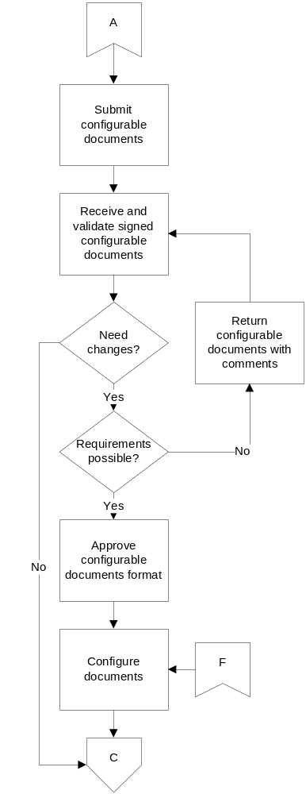 | Client  Refer to V-G, VI-F  Client  Refer to V-H, VI-G  Client  Refer to VI-H  Refer to VI-I  System Analyst  Refer to V-I, VI-H
System Analyst  Development Team  Project Manager | 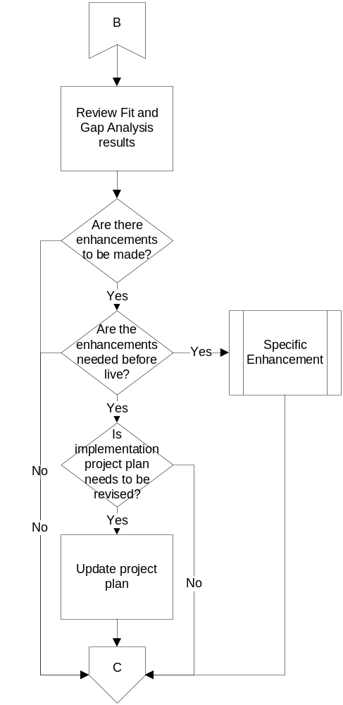 | Refer to V-J  Client  Refer to VI-J
Quality Analyst  Implementation Team  Implementation Team  System Analyst | 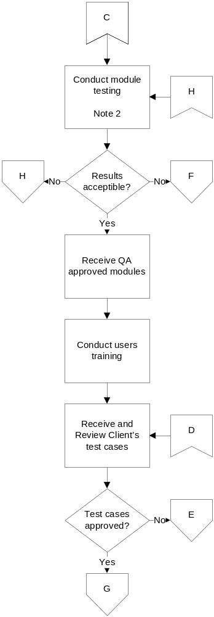 | Refer to V-K, VI-H  Quality Analyst  Client  Refer to V-L, VI-K  Client  Refer to V-M
Implementation Team  Quality Analyst  Database Administrator  Implementation Team  Project Manager  Project Manager, Implementation Team | 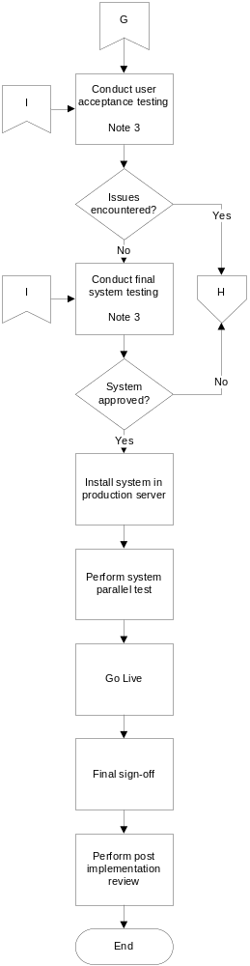 | Client  Refer to V-N, VI-L  Refer to V-O  Client  Refer to V-P, VI-M  Client  Client  Refer to VI-N  Client  Refer to V-Q, VI-O
Implementation Team, Quality Analyst | 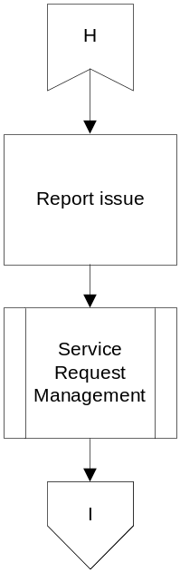 | Refer to VI-P

Notes:

- Pre-kick off meeting with the client should be made to discuss the project plan, implementation team (client and CPI) and their roles.

- Module to be tested can either be a configurable document or the whole system itself. If problem encountered is regarding configurable document, then module will be returned to the developer but if it is a system error then a service request will be filed.

- An issue can be identified if it is from the UAT or final testing based on the service request log.

V. REFERENCES

- Meeting Minutes Template
- Project Plan
- Project Budget Guidelines
- Project Cost Monitoring Template

- Project Plan
- Implementation Team

- Fit and Gap Analysis Guidelines
- Fit and Gap Analysis Minutes Template
- Fit and Gap Analysis Check list

- Fit and Gap Analysis Results Template

- Sample Test Cases

- Guidelines on Building Reference Tables
- Reference Table Document Templates
- System Parameter Log Template
- Chart of Accounts
- Data Dictionary
- ERD

- Standard Programming Checklist
- Configurable Documents Guidelines
- Configurable Documents Sample format
- Configurable Document Log Template

- Configurable Documents Guidelines
- Signed Configurable Documents format

- Signed Configurable Document Sample format
- Programming Guidelines

- Fit and Gap Analysis Results

    - Signed Configurable Document Sample Format
    - Test Scenarios
    - Test Cases
    - User’s Manual
    - Data Dictionary
    - ERD

- User Training Guidelines
- User Training Checklist
- User Training Topics
- User Training Exercises
- User Training Feedback Form
- User’s Manual

- Signed User Acceptance Test Cases/Scenario
- User Acceptance Test Cases Guidelines

- Signed User Acceptance Test Cases/Scenario
- User Acceptance Testing Guidelines
- User’s Manual

- Test Cases/Scenario
- User’s Manual
- Data Dictionary
- ERD

- Guidelines on Software Installation
- Installation Checklist

- Post Implementation Result Template
- Post Implementation Review Guidelines

- RECORDS

- Meeting Minutes
- Project Plan
- Project Cost Monitoring

- Fit and Gap Analysis Minutes

- Signed Fit and Gap Analysis Results

- Sample Test Cases Acceptance Slip

- Reference Table Documents
- Reference Table Checklist
- System Parameters Log

- Configurable Document Log
- Sample Configurable Documents Acceptance Slip

- Signed Configurable Documents – Summary
- Configurable Document Log

    - Configurable Document Log

    - Configurable Document Log
    - Signed Configurable Document Sample Format

- Project Plan
- Change Request

- Attendance List
- User Training Exercises Results
- Filled –up User Training Feedback Form

- User Acceptance Testing Signoff
- User Acceptance Testing Signoff – Summary

- Software Installation Documentation

- Final Sign-off Letter

- Post Implementation Result

- Service Request Log

Prepared by  Anne Rosario | Reviewed by | Approved by

